X Y

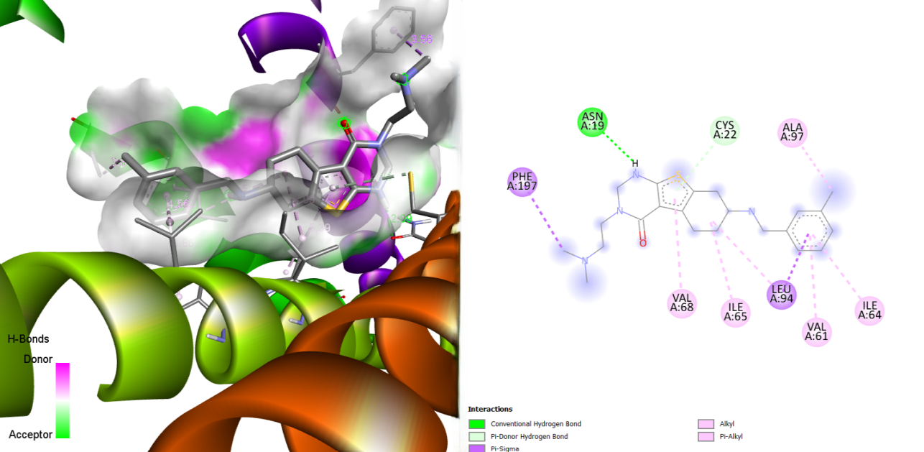
Figure S4 : Illustration of (X) 3D and (Y) 2D visualization of the interaction between the 23 kDa integral membrane protein (AF-Q26499-F1) and the ligand MMV006344.

