X Y
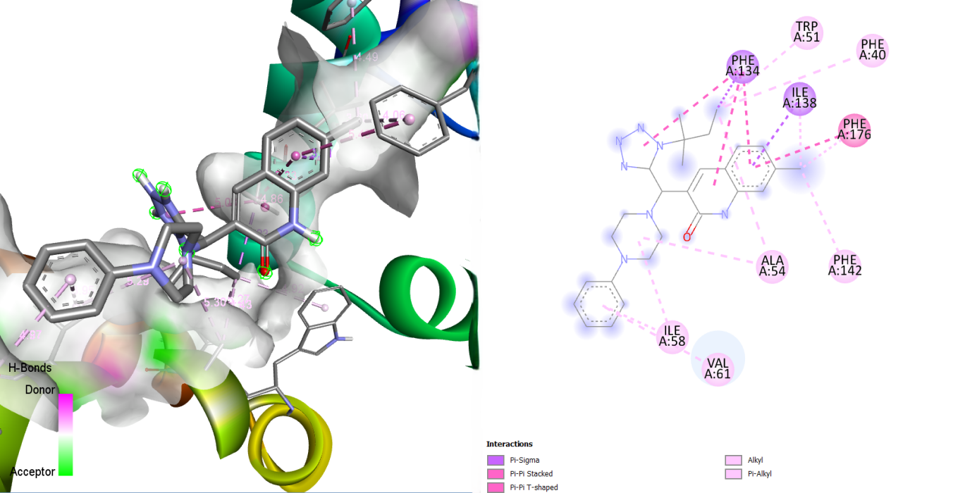

Figure S7: Illustration of (X) 3D and (Y) 2D Visualization of the Interaction Between the 23 kDa Integral Membrane Protein (AF-Q26499-F1) and the Ligand MMV007282

