X Y
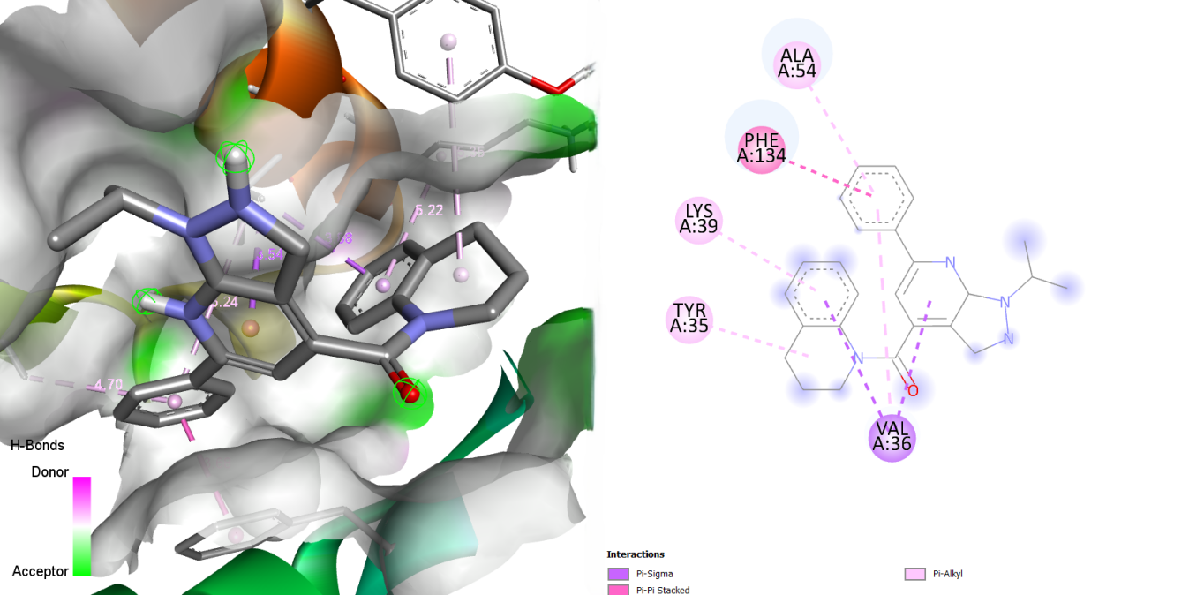
Figure S12: Illustration of (X) 3D and (Y) 2D visualization of the interaction between MMV020709 and the 23 kDa integral membrane protein (AF-Q26499-F1).

