X Y
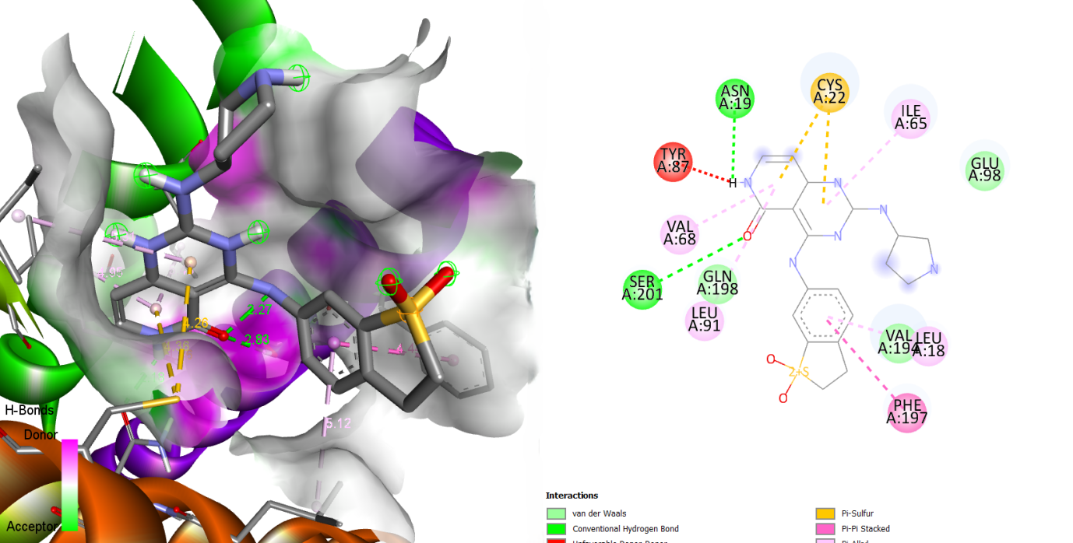
Figure S20: Visualization of (X) 3D and (Y) 2D interactions between MMV024850 and the 23 kDa integral membrane protein (AF-Q26499-F1).

