X Y
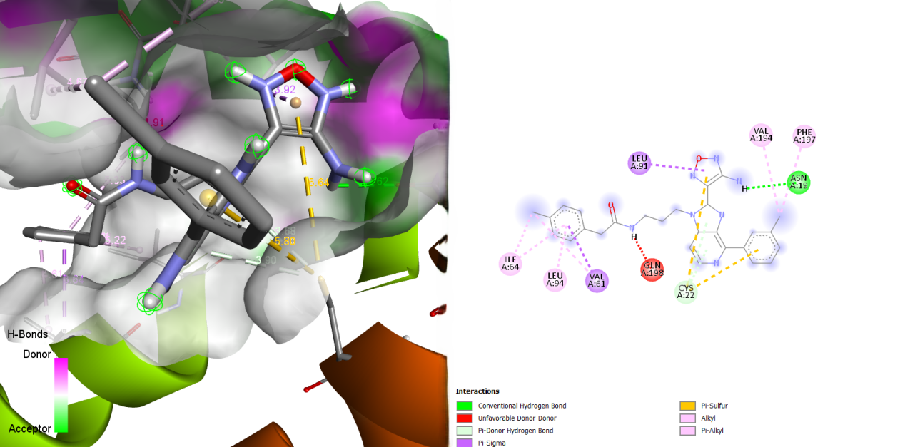

Figure S21: Illustration of the Binding Interactions of MMV025013 within the Active Site of the 23 kDa Membrane Protein (AF-Q26499-F1) .

