X Y
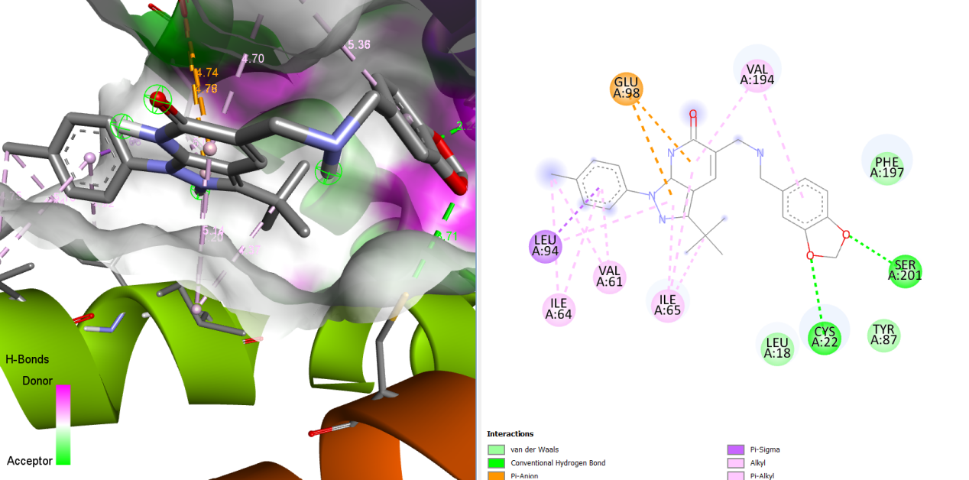

Figure S22: Illustration of the Binding Interactions of MMV026458 within the Active Site of the 23 kDa Membrane Protein (AF-Q26499-F1).

