X Y
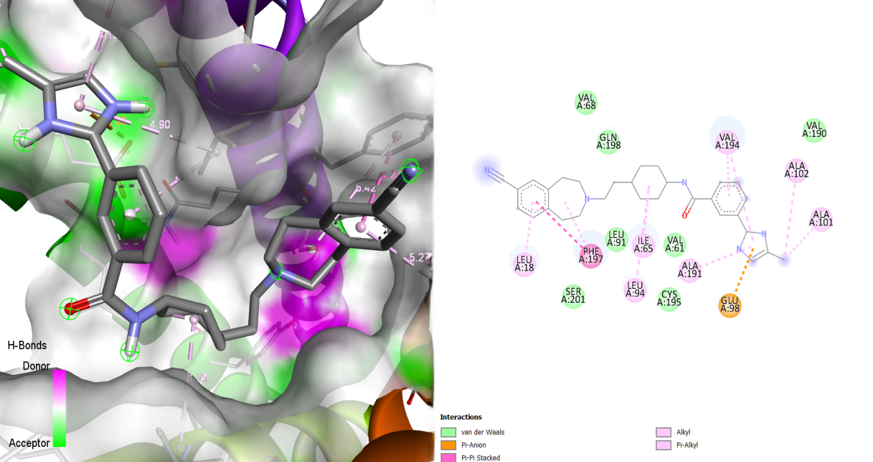
Figure S23: Illustration of the Binding Interactions of MMV029587 within the Active Site of the 23 kDa Membrane Protein (AF-Q26499-F1).

