X Y
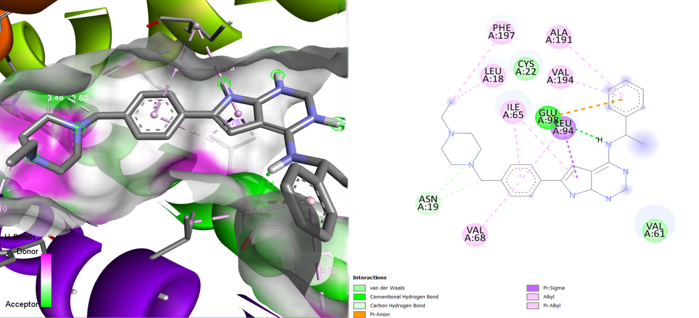
Figure S25: Illustration of the Binding Interactions of MMV1167451 within the Active Site of the 23 kDa Membrane Protein (AF-Q26499-F1).

