X Y
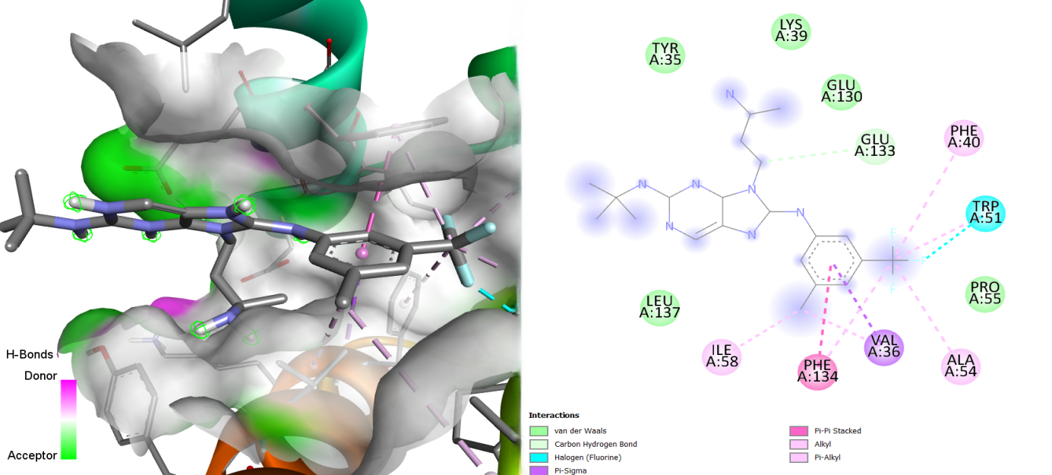
Figure S27: Illustration of the Binding Interactions of MMV1542799 within the Active Site of the 23 kDa Membrane Protein (AF-Q26499-F1).

