X Y
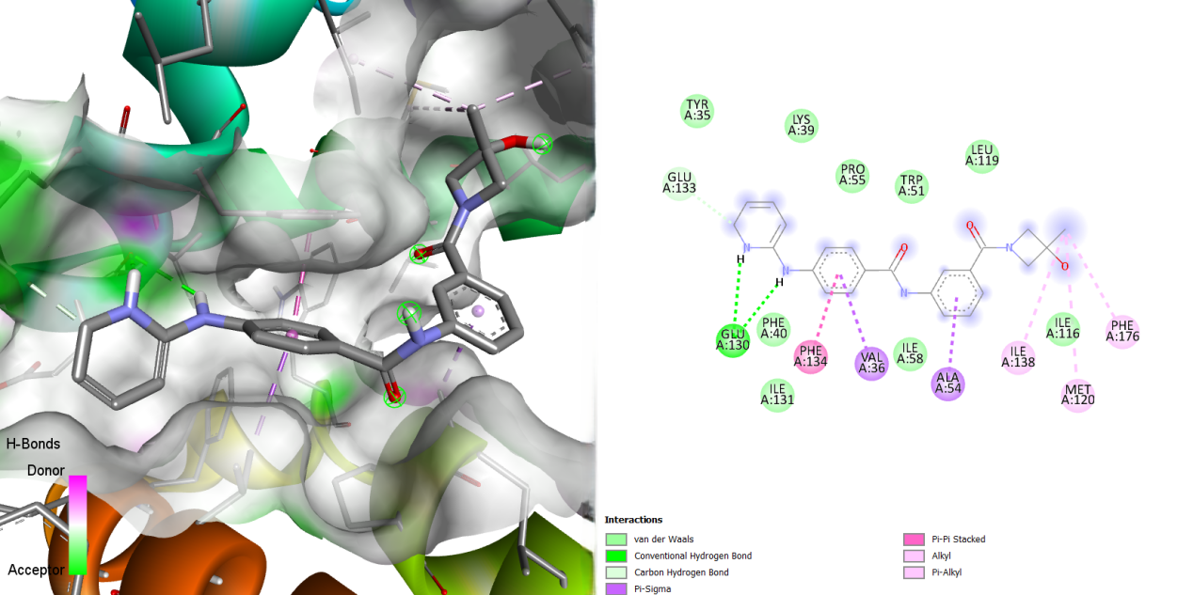
Figure S29: Illustration of the Binding Interactions of MMV1542822 within the Active Site of the 23 kDa Membrane Protein (AF-Q26499-F1).

